Assignment 3
Operation Result Pattern
The purpose of this assignment is to implement the Operation Result Pattern, which will then be used throughout your project in the future.
All assignments will be handed in through GitHub, and you must follow the structure described in the assignment descriptions.
First, follow the below steps to setup your project for assignment 3.

Documentation
Here goes the documentation for this assignment. A class diagram, maybe some more stuff.

Solution setup
First, you must setup the source code structure. Now you actually need to write code, so we start on the adventure of defining the architecture, which here is materialized as folders and projects (assemblies), and their relationships/dependencies.
The Operation Result implementation will go into the Tools layer, as it is to be used throughout the project. Every corner of your project needs access to the Operation Result, and in turn it depends on nothing.
Solution folder
First, create a new solution folder, call it “src”:
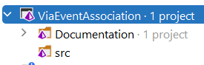
This folder will contain all our “production code”, i.e. the code used in to run the application. We will later have a separate “tests” solution folder.
Folder structure
Inside “src”, we put all the source code. Expand the solution folder structure like below, with a Core solution folder:
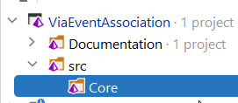
Core will contain application/use cases, the domain model, and our tools (you may also create a separate folder for tools, outside core).
Inside Core, create another solution folder called Tools:
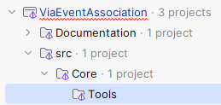
Inside Tools, create a new Class Library project, call it “<application name>.Core.Tools.OperationResult”, e.g.:
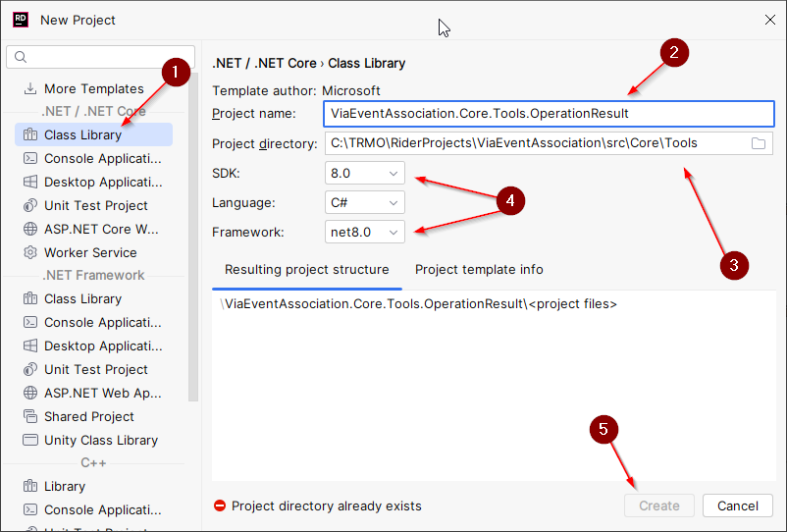
- It’s a Class Library
- The name of the class library. This naming approach is common convention, it minimizes potential namespace clashes with e.g. 3rd party libraries, because we prefix it with our own application name.
Similarly, if you go deeper with DDD, you will have bounded contexts, and each of these may have projects with similar names.
If you are doing a different project case, name the class library accordingly.
- Again, notice the path of the class library, the physical path i.e. location in your file explorer matches that of the solution folder structure. It just makes it easier to navigate your code, when viewed outside of an IDE, like GitHub.
- Make sure to use the current stable .NET release, at the time of writing it is .NET8.
You may verify the solution folder path and physical path matches, by checking the location of the project in the file explorer:

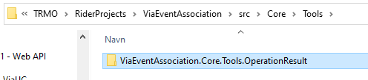

Git
Now, remember to add the ViaEventAssociation.Core.Tools.OperationResult.csproj file to git! And delete the dummy Class1.cs file in the new project.
Project structure
This time, we don’t require much structure. The OperationResult project will contain 1-3 files, probably. So, it’s up to you how you organize this project. You don’t even need directories, if you don’t feel like it.

Your Task
Implement the Operation Result Pattern, with extra features.
Basic Result
Start with a basic implementation, with the class containing the value and a potential error message.
This implementation will probably not take you far, however.
Consider whether you want two implementations:
- one with a payload, and one without
or
- one with a payload, and a “None”/”Unit” class
or
- some other combination..? Maybe you can surprise me.

Multiple Errors
Your Result class must be able to contain multiple errors. Consider how best to collect multiple errors in your Result. There are different approaches.

Error Codes
Your errors must now at least have both an error code/ID and an error message. Optionally an error-type-code.

Optional requirements
- Static factory methods to easier create success and failure results.
- Have errors as constants in separate classes (these would go into the Domain, so you may want to hold off on these until later).
- Helper methods to combine multiple results into one (or collect errors from multiple into one).
- Implicit operator/conversion.
- I have a bunch of extra stuff to enable simpler validation of business rules, and “railway oriented programming”, which is concept from functional programming. The point here is just that you can do a lot with this approach to really change your programming style.
You may also find that some of these requirements make more sense as you progress in the project, and it is certainly okay to update your result along the way.
Comment: My own implementation of the Result has evolved quite significantly during the implementation of the project, and the next project, as I needed more and more utility methods. You may find yourself in a similar situation, and you are welcome to expand the class as needed.

Design
You must create a class diagram of your result and associated classes. Maybe you have an error class or a None class/record or something else. And your Result probably has a few methods.

Test (optional)
You may wish to test your Result.
You could create a temporary console application project, and just play around with your result in the main method.
Or better: create unit tests.
We will deal with testing later in session 4, but to get you started, do as follows:
Create a new solution folder, at the root, next to “src” and “Documentation”. Call it “Tests”.
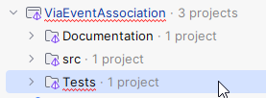
Inside this solution folder, create a new project, as seen below. In this course you will be introduced to the unit test framework xUnit.NET. Others exist. If you are more familiar with another framework, e.g. MSTest, or NUnit, or whatever, you can freely pick your favourite.
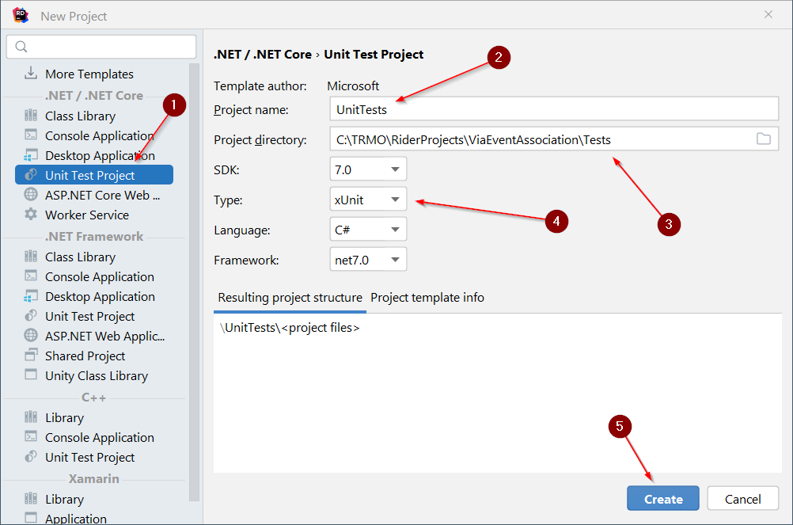
- Select this type of project.
- Give it a name, “UnitTests” seems good. You will later have integration tests as well; they will go in a different project.
- Match the physical path.
- Select testing framework.
- Create project.
To get a feel for the xUnit workings, you can read the first couple of sections from here: Quick introduction to xUnit.net - Meziantou's blog
We will later delve more into unit testing.
Create a folder “OperationResult”, or something similar. Put your tests in here.
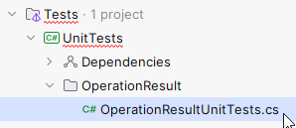

Formalities
- Feedback on the project?
Any feedback you encounter, put this in a markdown file in the Docs folder.
- Is something in the project descriptions unclear?
- Is information missing?
- Are use case scenarios missing, unclear, wrong? Anything else at all?
- Other?
Any feedback is valuable.

If you do any research yourselves, and find relevant sources, which you feel other students may benefit from, please put these in the markdown file as well. I can then add them to the course documentation.

- Handing in
You do not need to hand in. You just need everything ready before the exam.
There is no assignment on ItsLearning.

